SPANISH SPEAKING COUNTRIES OF THE WORLD
The 21 countries that have Spanish as the Official Language
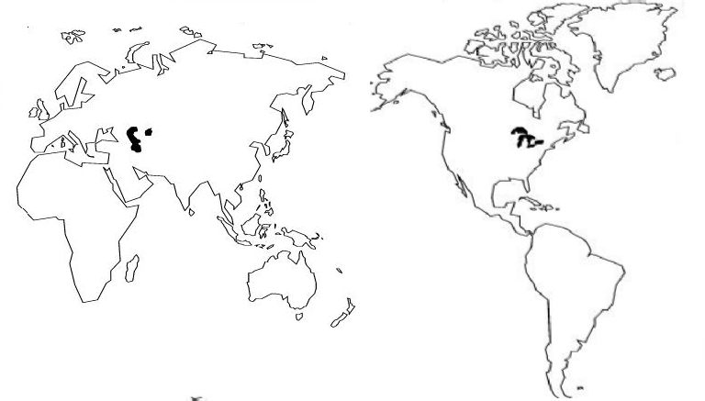
EUROPA

COUNTRYCAPITAL CITY

España Madrid

EL CARIBE (THE CARIBBEAN)

COUNTRYCAPITAL CITY

Cuba La Habana
La República Dominicana Santo Domingo
Puerto RicoSan Juan

NORTE AMÉRICA

COUNTRYCAPITAL CITY

MéxicoMéxico D.F.
ÁFRICA

COUNTRYCAPITAL CITY

Guinea Ecuatorial Malabo

SUDAMÉRICA / AMÉRICA DEL SUR

COUNTRYCAPITAL CITY

ArgentinaBuenos Aires
Bolivia La Paz
ChileSantiago
Colombia Bogotá
EcuadorQuito
ParaguayAsunción
PerúLima
UruguayMontevideo
VenezuelaCaracas

CENTROAMÉRICA / AMÉRICA CENTRAL

COUNTRYCAPITAL CITY

Costa Rica San José
GuatemalaGuatemala
HondurasTegucigalpa
NicaraguaManagua
PanamáPanamá
El SalvadorSan Salvador

EXTRA CREDIT – (COUNTRIES ONLY):

Belice: Below Mexico and next to Guatemala in Central America. English is the official language.
Jamaica: The island below Cuba in the Caribbean. English is the official language.
Haiti: Island to the right of Cuba - the left half of the island only. French is the official language.
Portugal: Next to Spain (España) on the left side, in Europe. Portuguese is the official language.
Sudamérica

Instructions - On the map: Correctly label the 9 Spanish-speaking countries of South America, and each capital city. Mark the capital city with a dot or star where each city is located.
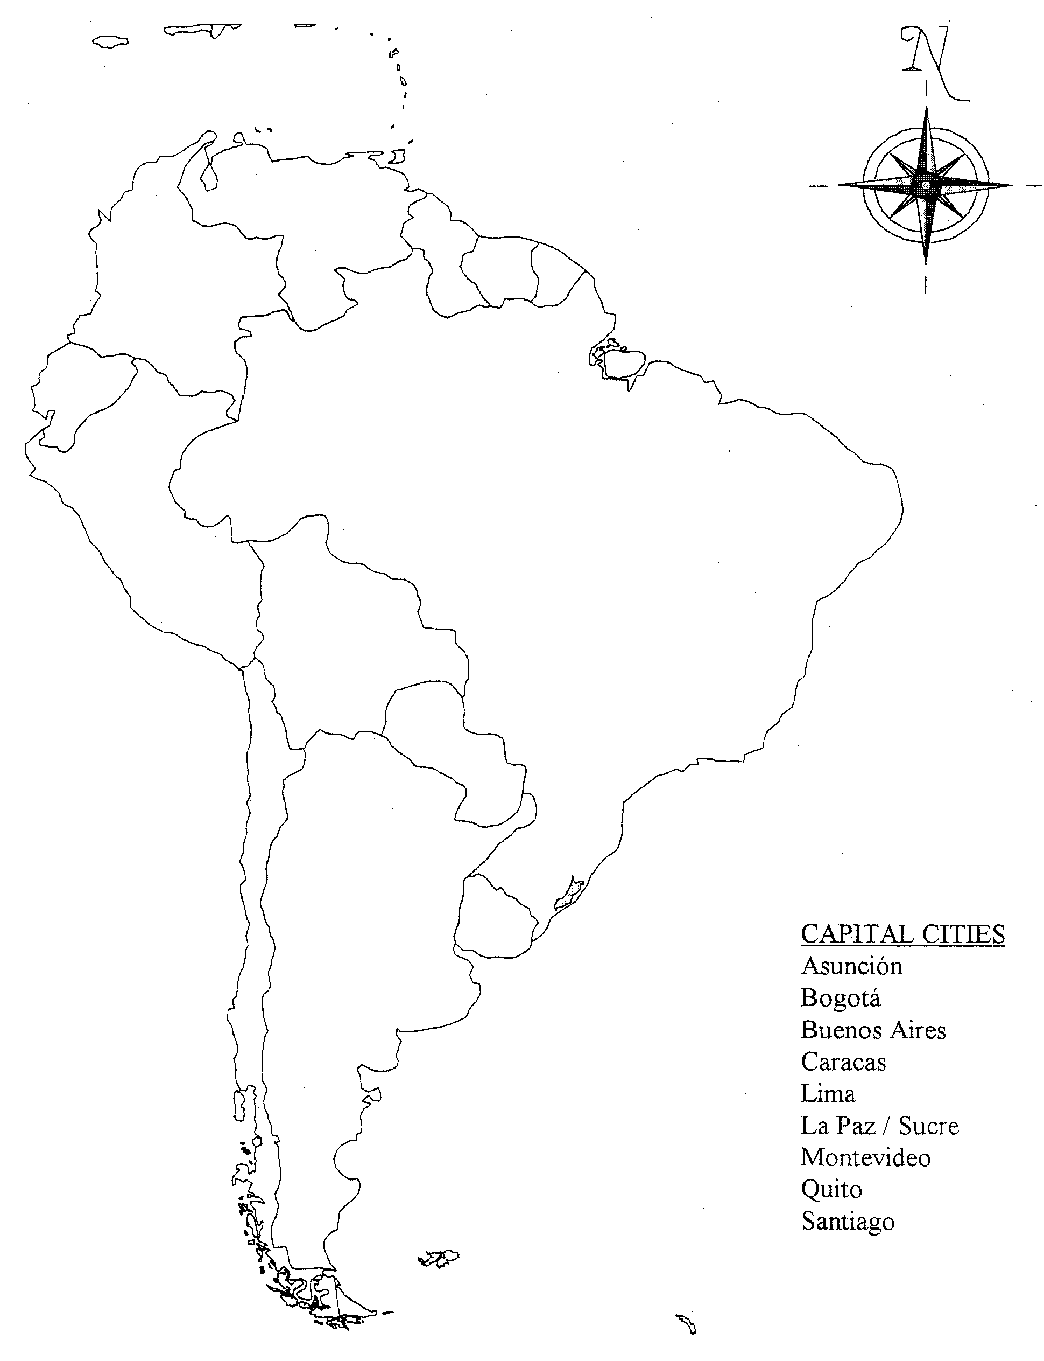

COUNTRIES

Argentina
Bolivia
Chile
Colombia
Ecuador
Paraguay
Perú
Uruguay
Venezuela

CAPITAL CITIES

Asunción
Bogotá
Buenos Aires
Caracas
Lima
La Paz
Montevideo
Quito
Santiago

____ / 18

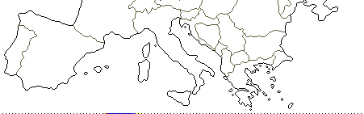
Instructions - On the map: Correctly label the one Spanish-speaking country in Europe and the one Spanish-speaking in Africa. Also correctly label the capital city of each country in its approx. location.

EUROPA

Portugal

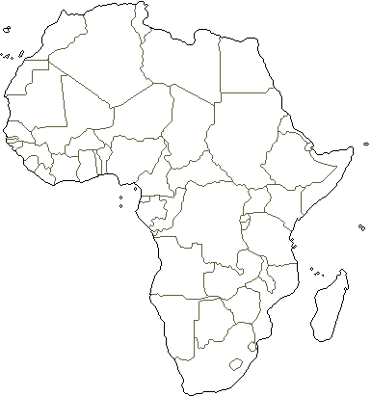

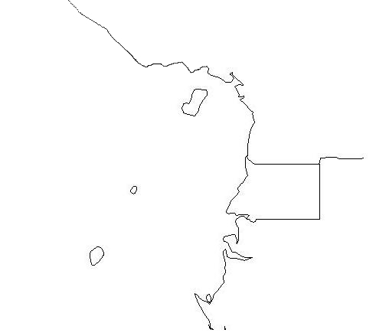
ÁFRICA

CAPITAL CITIES

Malabo
Madrid

COUNTRIES

Madrid
Guinea Equatorial

COUNTRIES

España
Guinea Ecuatorial

COUNTRIES

Madrid
Guinea Equatorial

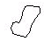

____ / 4

INSTRUCTIONS:
On the map label the 1 country in Norteamérica, the 6 countries of Centroamérica and the 3 countries in El Caribe where Spanish is the official Spoken language.

Countries

Costa Rica
Cuba
El Salvador
Guatemala
Honduras
México
Nicaragua
Panamá
Puerto Rico (territory of U.S.)
República Dominicana

EL CARIBE

Capital Cities

Guatemala
La Habana
Managua
México D.F.
Panamá
San José
San Juan
San Salvador
Santo Domingo
Tegucigalpa

NORTEAMÉRICA

Belice

Jamaica
Haiti

CENTROAMÉRICA

Malabo 
\South America Pkt & Test \Central America Map.doc
____ / 20

